PART 1
QUESTIONS:
1. After applying the “http.request.method == POST”. Provide a screenshot of the
filtered packets
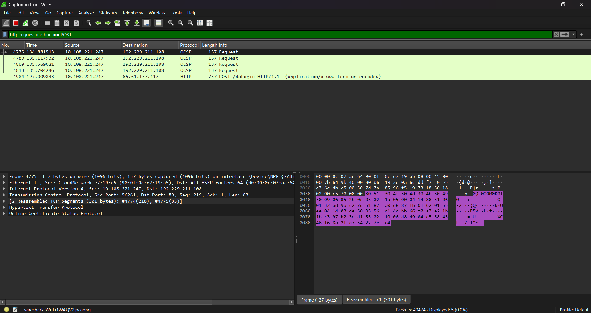

2. Which of the filtered packets contain the password?
- The last packet with the HTTP protocol.
3. On which layer was the password found?
- Layer 5 or the application layer.

4. Provide a screenshot of the frame details and the layer that contains the password.
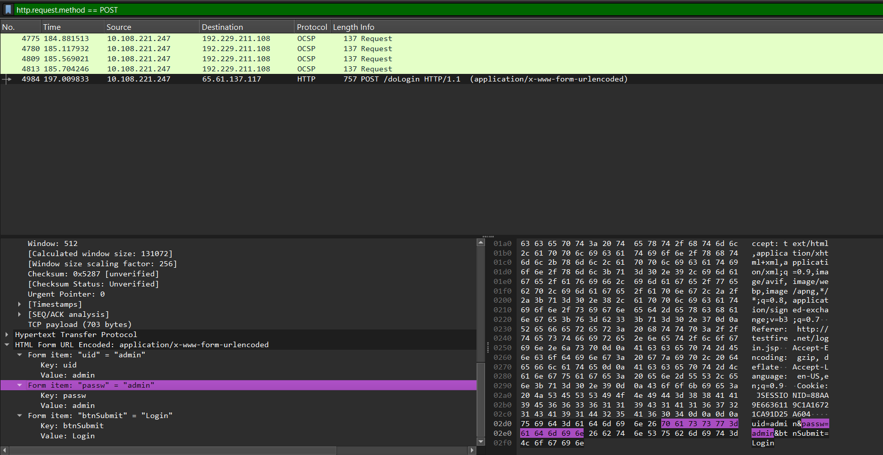
PART 2
- How many packets are for icmp?
- 2500

- How many packets are for udp?
- 3000

- How many packets are for tcp?
- 5000

4.1 How many entries are listed in the Ethernet protocol?
- 2
4.2 Answer for each entry in the Ethernet Protocol
i. Packets
Entry 1: 10,500
Entry 2: 10,500
ii. Bytes
Entry 1: 501 kB
Entry 2: 501 kB

iii. Transmitted (Tx) Packets
Entry 1: 0
Entry 2: 10,500
iv. Transmitted (Tx) Bytes
Entry 1: 0 bytes
Entry 2: 501 kB
v. Received (Rx) Packets
Entry 1: 10,500
Entry 2: 0

vi. Received (Rx) Bytes
Entry 1: 501 kB
Entry 2: 0 bytes

5.1 How many entries are listed in the IP protocol?
- 10501
5.2 What is the total packet number sent for each entry in general? Are all of
them the same?
- The total packet number sent for each entry in general is 1, however, there is one entry that has 0 packets sent or transmitted.

6.1 How many entries are listed in the TCP protocol?
- 5001
6.2 What is the total packet number sent for each entry in general? Are all of
them the same?
- The total packet number sent for each entry in general is 1. All of them are the same.

7.1 How many entries are listed in the UDP protocol?
- 3001
7.2 What is the total packet number sent for each entry in general? Are all of
them the same?
- The total packet number sent for each entry in general is 1, however, there is one entry that has 0 packets sent or transmitted.

